**Functions Part 1 Creating and Calling Functions**

**Functions:**

A function is simply **a “chunk” of code that you can use over and over again, rather than writing it out multiple times**.

* Functions enable programmers to break down or decompose a problem into smaller chunks, each of which performs a particular task.

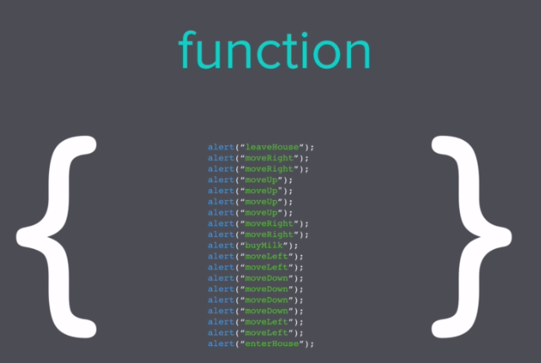

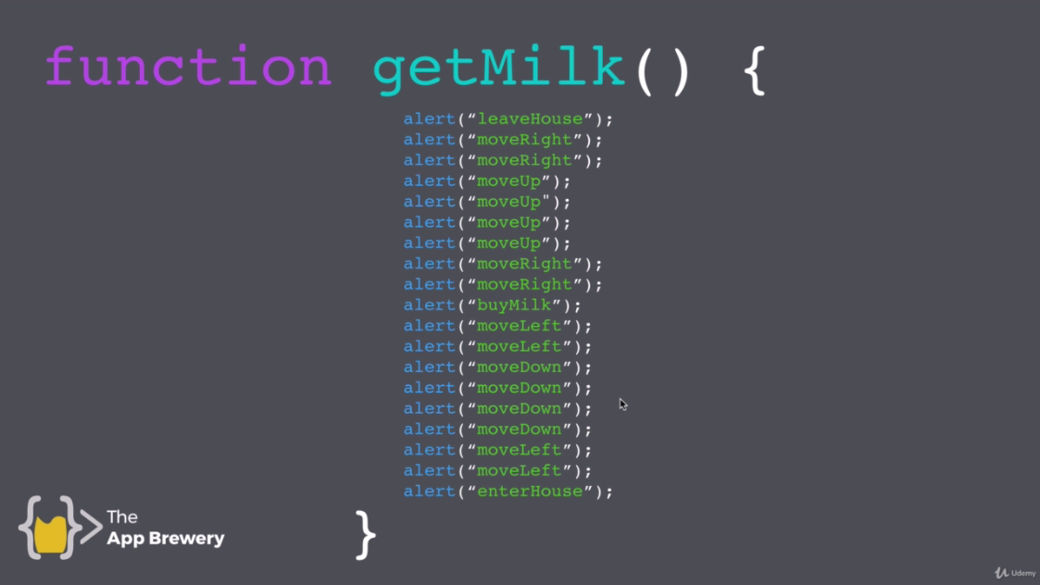

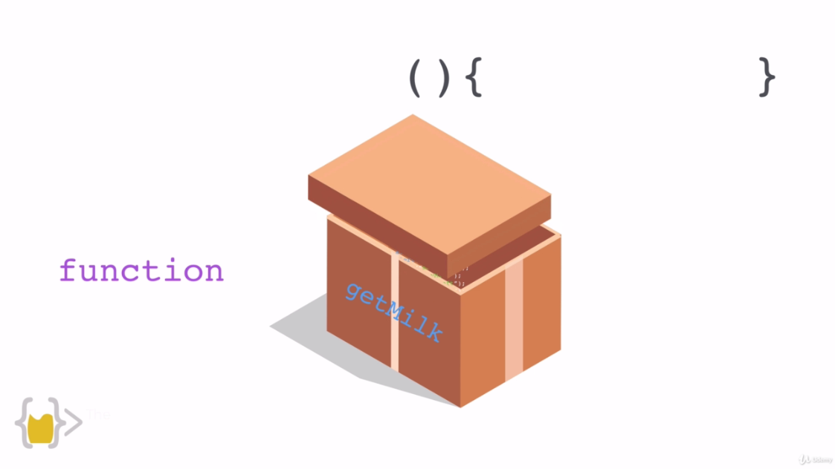

Functions involve function calling.

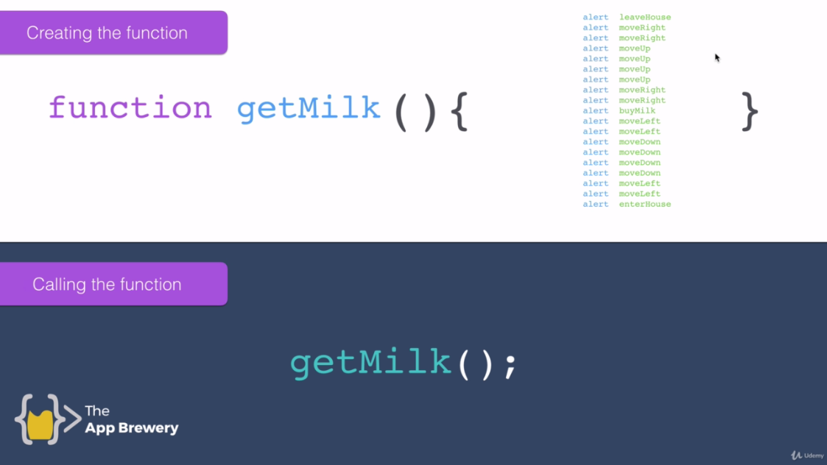

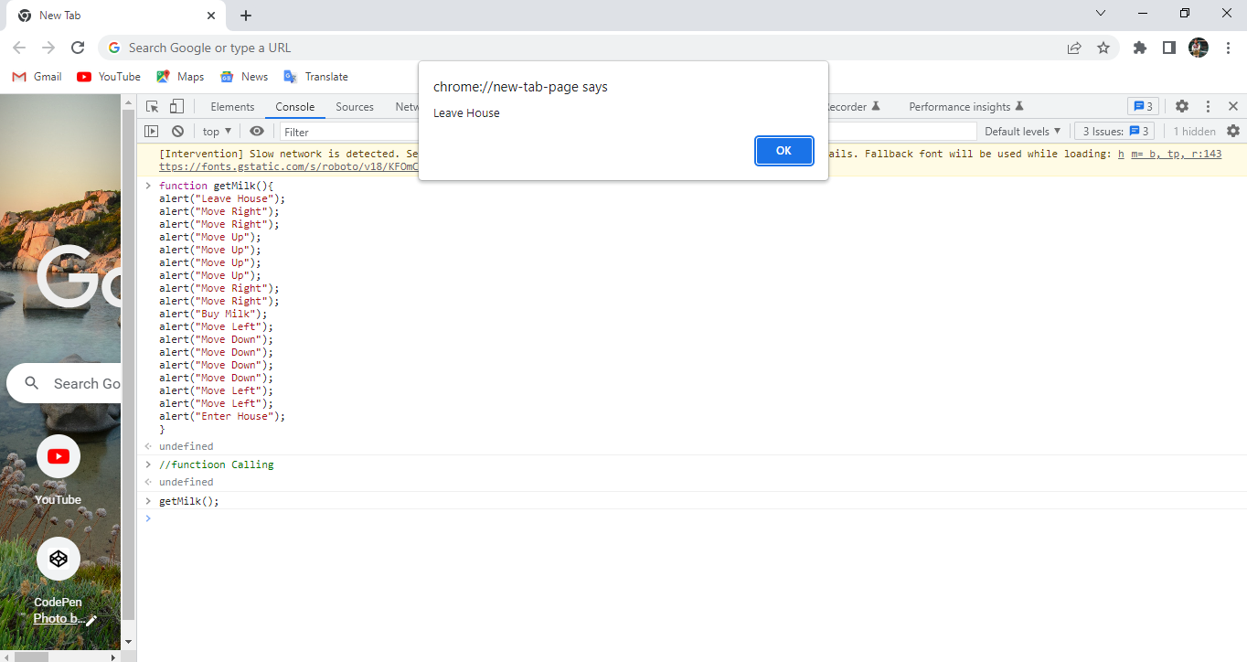

These commands will run one by one. Click ok to get next command.

function getMilk(){

alert("Leave House");

alert("Move Right");

alert("Move Right");

alert("Move Up");

alert("Move Up");

alert("Move Up");

alert("Move Up");

alert("Move Right");

alert("Move Right");

alert("Buy Milk");

alert("Move Left");

alert("Move Down");

alert("Move Down");

alert("Move Down");

alert("Move Down");

alert("Move Left");

alert("Move Left");

alert("Enter House");

}

//Function call

getMilk();

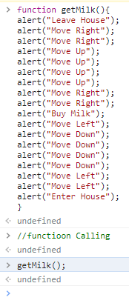

Replace **alert** with **console.log**

function getMilk(){

console.log("Leave House");

console.log("Move Right");

console.log("Move Right");

console.log("Move Up");

console.log("Move Up");

console.log("Move Up");

console.log("Move Up");

console.log("Move Right");

console.log("Move Right");

console.log("Buy Milk");

console.log("Move Left");

console.log("Move Down");

console.log("Move Down");

console.log("Move Down");

console.log("Move Down");

console.log("Move Left");

console.log("Move Left");

console.log("Enter House");

}

//Function call

getMilk();

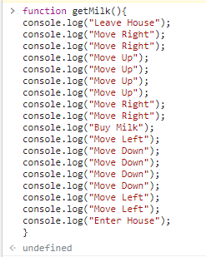

Result:

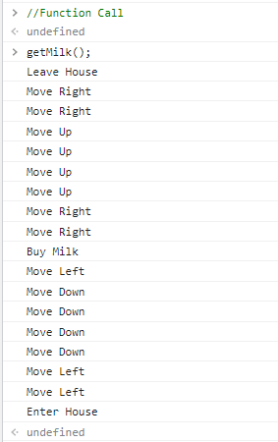

**Note:**

Console.log is only for developer to debug the code.